AVALON WATER AND SEWER SERVICE CORP
PO Box 70 | AGENDA | Avalon, Texas 76623  Phone: 972-627-0044
Officers |  | Directors
Kay Leamon, President |  | David Waishes
Jacob Carter, Vice-President |  | Jimmy Brown
Robin Donaldson, Secretary/Treasurer |  | Carson Hastings
Matilda Williams

Notice of Special Meeting for May 26.2016
To All Members:
A special meeting of the Board of Directors of Avalon Water Supply and Sewer Service Corp will be held on Thursday, May 26, 2016 at 7:00 pm at the First Baptist Church, 206 Giles St., Avalon, TX. The governing body of Avalon Water Supply and Sewer Service Corporation reserves the right to adjourn into closed/executive session at any time during the course of this meeting to discuss any of the matters listed in this agenda, in the order deemed appropriate, and authorized by Texas Government Code 551, or to seek the advice of an attorney on any matter in which the duty of the attorney to Avalon Water Supply and Sewer Service Corporation board under Texas Disciplinary Rules of Professional Conduct of the State Bar of Texas clearly conflicts with Texas Government Code Chapter 551 or as otherwise may be permitted under 551.
The agenda for the meeting is as follows:
l . Call meeting to order,
- Determine presence of a quorum.
- Declare notices legally posted pursuant to Open Meetings Act.
Action Agenda: The Board reserves the right on all matters listed under this section to take action by motion and vote. Said action including but not limited to; Discuss, amend, table, approve or reject as is determined appropriate by the majority of the quorum.
- Close session under Section 551.071 Discussion and Possible Decisions on Gillespie PUC Complaint with Attorney.
- Possible Vote on Gillespie PUC Complaint Actions or Responses.
- Close session under Section 551.071 Discussion and Possible Decisions on Gillespie Easement Complaint with attorney.
- Possible Vote on Gillespie Easement Complaint Actions or Responses.
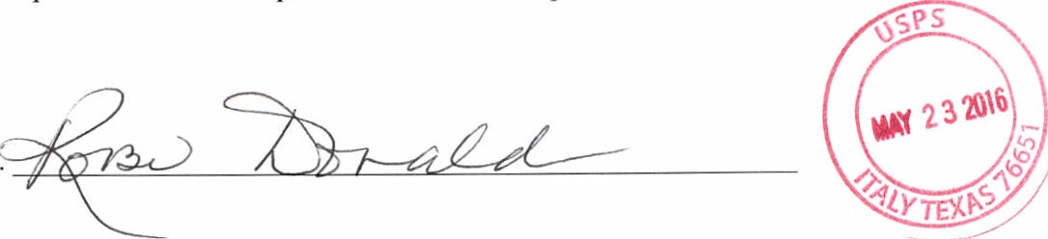
- Adjournment.
Robin Donaldson, Sect-Treas.

